PC Picture  January Mission #1:  Stone Buddha Market | 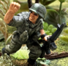 | 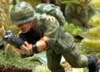 | 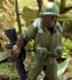 | 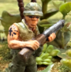 | 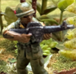
Name: | Sgt. Hayes | Cpl. Kern | Pfc. Tatum | Pfc. Cassidy | Pvt. Parker
Weapon – Experience (#): | M16 - Veteran | M16 - Grunt (3) | M16 - Grunt (2) | M79 - Grunt (4) | M16 - FNG (2)
Trait(s): | Frosty, Gung Ho | Frag Man | I Can Take It! | Handy with That
Results & Recover:  (see table on Page 20) | Messed up  LOST A LIMB | Walking Wounded BAD LUCK  (Back next month!) | Lightly Wounded  (REMF -  Miss 1 month) | ESCAPED  OFF-TABLE | ESCAPED  OFF-TABLE
PC Picture  February Mission #2: | Need to roll for a replacement; see table on Page 21. | 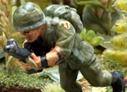 | Leave this slot blank for this mission | 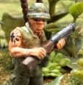 | 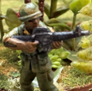
Name: | TBD | Cpl. Kern | NA | Pvt. Cassidy | Pfc. Parker
Weapon – Experience (#): |  | M16 - Grunt (3) |  | M79 - Grunt (4) | M16 - Grunt (5)
Trait(s): |  | Frag Man |  | Handy with That | Bac Si
Results & Recover:
(see table on Page 20)

PC Picture
March Mission #3:

Name:
Weapon – Experience (#):
Trait(s):
Results & Recover:
(see table on Page 20)

Note: (#) -- The number after Experience is the Mission # that the PC is eligible to gain a trait. Page 1
PC Picture
April Mission #4:

Name:
Weapon – Experience (#):
Trait(s):
Results & Recover:
(see table on Page 20)

PC Picture
May Mission #5:

Name:
Weapon – Experience (#):
Trait(s):
Results & Recover:
(see table on Page 20)

PC Picture
June Mission #6:

Name:
Weapon – Experience (#):
Trait(s):
Results & Recover:
(see table on Page 20)

Note: (#) -- The number after Experience is the Mission # that the PC is eligible to gain a trait. Page 2
PC Picture
July Mission #7:

Name:
Weapon – Experience (#):
Trait(s):
Results & Recover:
(see table on Page 20)

PC Picture
August Mission #8:

Name:
Weapon – Experience (#):
Trait(s):
Results & Recover:
(see table on Page 20)

PC Picture
September Mission #9:

Name:
Weapon – Experience (#):
Trai(s)t:
Results & Recover:
(see table on Page 20)

Note: (#) -- The number after Experience is the Mission # that the PC is eligible to gain a trait. Page 3
PC Picture
October Mission #10:

Name:
Weapon – Experience (#):
Trait(s):
Results & Recover:
(see table on Page 20)

PC Picture
November Mission #11:

Name:
Weapon – Experience (#):
Trait(s):
Results & Recover:
(see table on Page 20)

PC Picture
December Mission #12:

Name:
Weapon – Experience (#):
Trait(s):
Results & Recover:
(see table on Page 20)

Note: (#) -- The number after Experience is the Mission # that the PC is eligible to gain a trait. Page 4

